COMSATS University Islamabad (CUI) Attock Campus

**C**

**Final Term**

**MUHAMMAD YAQOOB CIIT/FA21-BCS-044/ATK**

**Submitted To: Dr. Bilal Haider  
subject: CC**

**Question 5: Explain function performs semantic analysis in mini compiler:  
  
Answer:**

**Screenshot:  
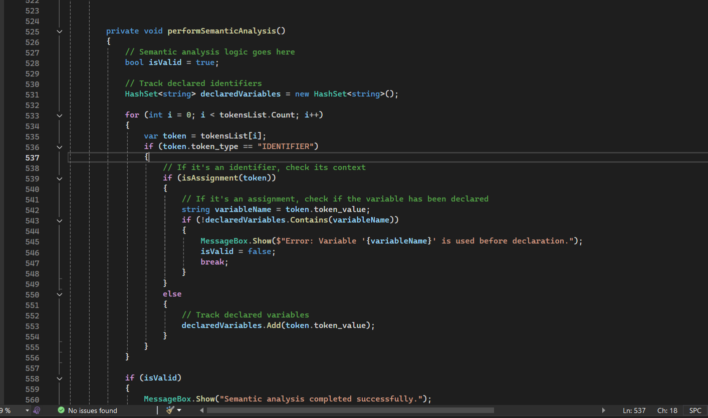**

**Code:** private void performSemanticAnalysis()

{

// Semantic analysis logic goes here

bool isValid = true;

// Track declared identifiers

HashSet<string> declaredVariables = new HashSet<string>();

for (int i = 0; i < tokensList.Count; i++)

{

var token = tokensList[i];

if (token.token_type == "IDENTIFIER")

{

// If it's an identifier, check its context

if (isAssignment(token))

{

// If it's an assignment, check if the variable has been declared

string variableName = token.token_value;

if (!declaredVariables.Contains(variableName))

{

MessageBox.Show($"Error: Variable '{variableName}' is used before declaration.");

isValid = false;

break;

}

}

else

{

// Track declared variables

declaredVariables.Add(token.token_value);

}

}

}

if (isValid)

{

MessageBox.Show("Semantic analysis completed successfully.");

}

}

// Check if the current token represents an assignment operation

private bool isAssignment(Token token)

{

return token.token_type == "ASSIGN";

}

### Explanation: Function of Semantic Analysis:

1. **Check Token Availability:**
   * The method button5_Click checks whether there are tokens to analyze. If tokensList.Count == 0, it displays a message and exits, as there are no tokens available for analysis.
2. **Start Semantic Analysis:**
   * If tokens are available, the performSemanticAnalysis method is called to check the logic of the program based on the tokens.
3. **Tracking Declared Variables:**
   * Inside performSemanticAnalysis, a HashSet<string> called declaredVariables is used to keep track of identifiers (variables) that have been declared. This helps in ensuring variables are used only after they are declared.
4. **Iterating Over Tokens:**
   * The method loops over each token in tokensList.
   * If the token type is "IDENTIFIER", it means it represents a variable in the program.
5. **Checking Assignments:**
   * If the token represents an assignment (i.e., the token is part of an assignment operation), the code checks whether the variable has been declared before.
   * This is done by looking up the variable name in declaredVariables.
     + If the variable is not found, an error message is displayed indicating that the variable is used before declaration, and the analysis stops.
     + If the variable is found, the program continues without an error.
6. **Tracking New Declarations:**
   * If the token is an identifier that is not part of an assignment (i.e., it's a new variable), it is added to declaredVariables.
7. **End of Analysis:**
   * After processing all tokens, if no errors were encountered (i.e., all variables were declared before being used), a success message is shown.

**Purpose of Semantic Analysis:**

* **Error Detection:** It checks that all variables are used in the correct context, ensuring that undeclared variables aren't used (which would lead to runtime errors).
* **Context Checking:** Beyond syntax checking (which happens in parsing), it ensures that the program’s meaning is valid by verifying the context in which tokens are used, such as ensuring variables are declared before assignment.

In summary, the semantic analysis in this code ensures that all variables are declared before they are used in assignment operations, helping to avoid logical errors in the code.